Mini-Project



Faculty Communication: Made Easy

A Web application

HTML | CSS | SQL

# A Report by

Tharun k

# Front-End Web Markup and Style By

Tharun k

# Faculties who guided us

harish sir

deepak sir

shubha bhat mam

# About The Team

tHARUN K – 1DS16CS114

RUTHWIK H PARAM – 1DS16CS125

PRATHVIRAJ – 1DS16CS

VISMAY B ANAND – 1DS16CS

About the Mini-Project

# What we provide:

1. We want to provide a platform for the faculties where they can communicate with each other in a quick way during the college hours.
2. Since using of mobile phones is not advised in the college campus, we will provide them an easy, comfortable and secure way to communicate with each other.

# The Login Facility:

1. There will be a unique username and password for the faculties to sign-in with.
2. They will be able to sign-in with their provided credentials.
3. Once they are logged-in they will be able to send the message to a

* Particular faculty
* A particular group of Faculty
* Or in a discussion page of a particular group

# Safe and Secure:

All the information discussed or announced inside this webpage will be secure and encrypted.

Your Contact information is safe with us.

# Notifications:

1. As soon as a faculty receives a message, the faculty is notified by,

* Desktop Notification
* Email
* Phone (If available)

1. So that they are immediately able to react to the important message they have received.

Technologies Used

# HTML:

HTML is the standard markup language for creating Web pages.

* HTML stands for Hyper Text Markup Language
* HTML describes the structure of Web pages using markup
* HTML elements are the building blocks of HTML pages
* HTML elements are represented by tags
* HTML tags label pieces of content such as "heading", "paragraph", "table", and so on
* Browsers do not display the HTML tags, but use them to render the content of the page

So we have used the HTML for our Mark-up.

We have also tried to make the code as simple as possible.

# CSS:

What is CSS?

* CSS stands for Cascading Style Sheets
* CSS describes how HTML elements are to be displayed on screen, paper, or in other media
* CSS saves a lot of work. It can control the layout of multiple web pages all at once
* External style sheets are stored in CSS files

We have provided the CSS Style sheet as style.css file.

# SQL:

What is SQL?

* SQL stands for Structured Query Language
* SQL lets you access and manipulate databases
* SQL is an ANSI (American National Standards Institute) standard

What Can SQL do?

* SQL can execute queries against a database
* SQL can retrieve data from a database
* SQL can insert records in a database
* SQL can update records in a database
* SQL can delete records from a database
* SQL can create new databases
* SQL can create new tables in a database
* SQL can create stored procedures in a database
* SQL can create views in a database
* SQL can set permissions on tables, procedures, and views

The Coding Part…

## there are these html files:

* Home.html
* Contact.html
* About.html
* Login.html

# Page 1: Home.html

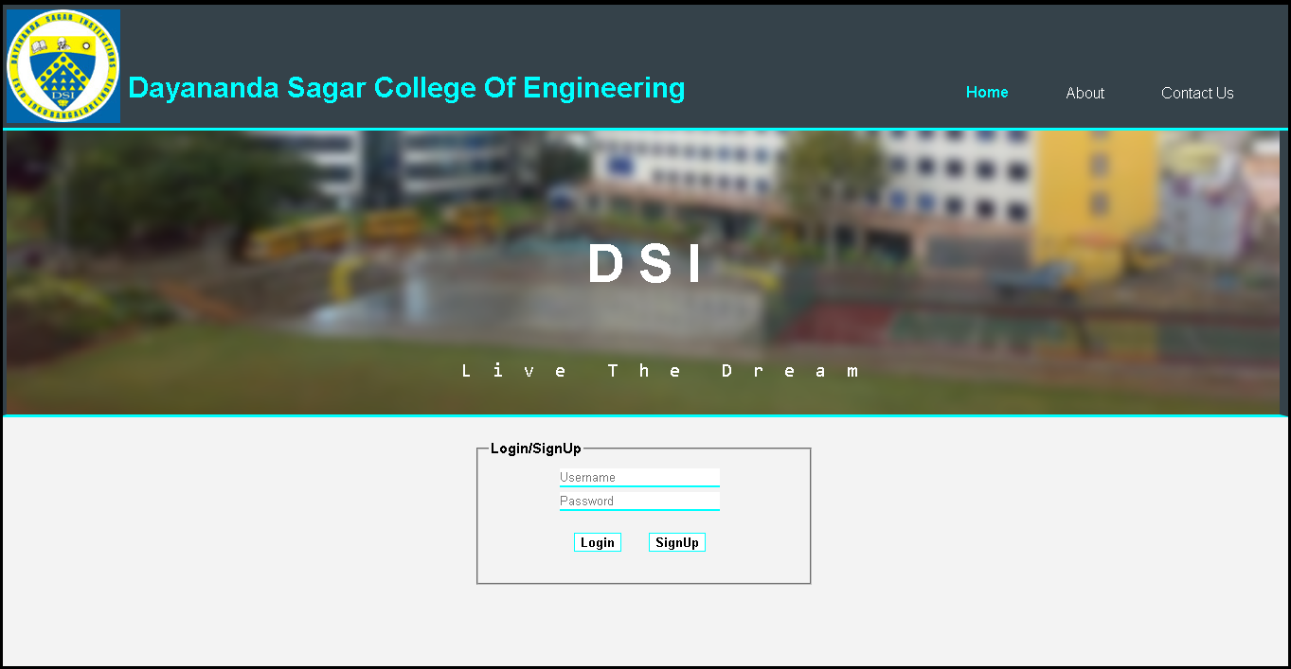

# The code:

<!-- A Front-end Design by Tharun K -->

<!DOCTYPE html>

<html>

<head>

<title>DSCE | Welcome</title>

<meta charset="UTF-8">

<meta name="keywords" content="dsce,dayananda,sagar,college,of,engineering,faculty,database,contact,faculties,mini,project">

<meta name="author" content="Tharun K">

<meta name="viewport" content="width=device-width,initial-scale=1.0">

<meta name="description" content="A faculty contact Database">

<link rel="stylesheet" type="text/css" href="./css/style.css">

</head>

<body>

<header>

<img src="./img/logo.gif" >

<div id="branding">

<h1>Dayananda Sagar College Of Engineering</h1>

</div>

<nav>

<ul>

<li class="current"><a href="home.html">Home</a></li>

<li><a href="about.html">About </a></li>

<li><a href="contactus.html">Contact Us</a></li>

</ul>

</nav>

</header>

<section id="showcase">

<div class="container">

<h1>D S I</h1>

<pre>

<p> L i v e T h e D r e a m</p>

</pre>

</div>

</section><br/>

<section id="login">

<div class="container">

<form >

<fieldset id="loginside">

<legend>Login/SignUp</legend>

<input class="ifield" type="text" autofocus name="username" placeholder="Username" ><br/>

<input class="ifield" type="password" name="password" placeholder="Password"><br/><br/>

<button id="log" type="submit" name="login" >Login</button>

<button id="sign" type="button" name="signup" >SignUp</button><br/><br/>

</fieldset>

</form>

</div>

</section>

</body>

</html>

# Page 2: About.html

# C:\Users\SONY\Pictures\Screenshots\Screenshot (244).png

# The Code:

<!-- A Front-end Design by Tharun K -->

<!DOCTYPE html>

<html>

<head>

<title>DSCE | About</title>

<meta charset="UTF-8">

<meta name="keywords" content="dsce,dayananda,sagar,college,of,engineering,faculty,database,contact,faculties,mini,project">

<meta name="author" content="Tharun K">

<meta name="viewport" content="width=device-width,initial-scale=1.0">

<meta name="description" content="A faculty contact Database">

<link rel="stylesheet" type="text/css" href="./css/style.css">

</head>

<body>

<header>

<img src="./img/logo.gif" >

<div id="branding">

<h1>Dayananda Sagar College Of Engineering</h1>

</div>

<nav>

<ul>

<li ><a href="home.html">Home</a></li>

<li class="current"><a href="about.html">About </a></li>

<li><a href="contactus.html">Contact Us</a></li>

</ul>

</nav>

</header>

<section id="showcase_about">

<div class="container">

<h1>D S I</h1>

<pre>

<p> L i v e T h e D r e a m</p>

</pre>

</div>

</section><br/>

<section id="about">

<div class="container">

<article>

<h3>About Us</h3>

<p><i>Front-end Webpage Design by </i></p>

<address>

Tharun K,<br/>

3rd Sem,<br/>

USN:1DS16CS114,<br/>

DSCE<br/>

</address>

</article>

<aside class="aside">

<h3>A Mini Project</h3>

<h4>Team Members</h4>

<p>

Tharun K - 1DS16CS114<br/>

Vismay B Anand - 1DS16CS***<br/>

Prathviraj - 1DS16CS***<br/>

Ruthwik H Param - 1DS16CS***<br/>

<p>

</aside>

</div>

</section>

<footer class="fabout">

<p><a href="contactus.html">Contact Us </a>for any Queries or to Report a bug </p>

</footer>

</body>

</html>

# Page 3: Contactus.html

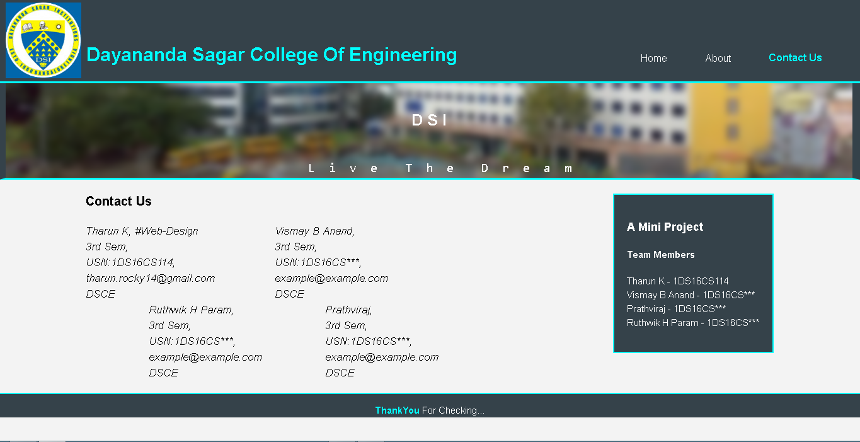

# The Code:

<!-- A Front-end Design by Tharun K -->

<!DOCTYPE html>

<html>

<head>

<title>DSCE | ContactUs</title>

<meta charset="UTF-8">

<meta name="keywords" content="dsce,dayananda,sagar,college,of,engineering,faculty,database,contact,faculties,mini,project">

<meta name="author" content="Tharun K">

<meta name="viewport" content="width=device-width,initial-scale=1.0">

<meta name="description" content="A faculty contact Database">

<link rel="stylesheet" type="text/css" href="./css/style.css">

</head>

<body>

<header>

<img src="./img/logo.gif" >

<div id="branding">

<h1>Dayananda Sagar College Of Engineering</h1>

</div>

<nav>

<ul>

<li ><a href="home.html">Home</a></li>

<li ><a href="about.html">About </a></li>

<li class="current"><a href="contactus.html">Contact Us</a></li>

</ul>

</nav>

</header>

<section id="showcase_about">

<div class="container">

<h1>D S I</h1>

<pre>

<p> L i v e T h e D r e a m</p>

</pre>

</div>

</section>

<section id="about">

<div class="container">

<article>

<h3>Contact Us</h3>

<address id="a1">

Tharun K, &#35;Web-Design<br/>

3rd Sem,<br/>

USN:1DS16CS114,<br/>

tharun.rocky14@gmail.com<br/>

DSCE<br/>

</address>

<address id="a2">

Vismay B Anand,<br/>

3rd Sem,<br/>

USN:1DS16CS***,<br/>

example@example.com<br/>

DSCE<br/>

</address>

<address id="a3">

Prathviraj,<br/>

3rd Sem,<br/>

USN:1DS16CS***,<br/>

example@example.com<br/>

DSCE<br/>

</address>

<address id="a4">

Ruthwik H Param,<br/>

3rd Sem,<br/>

USN:1DS16CS***,<br/>

example@example.com<br/>

DSCE<br/>

</address>

</article>

<aside class="caside">

<h3>A Mini Project</h3>

<h4>Team Members</h4>

<p>

Tharun K - 1DS16CS114<br/>

Vismay B Anand - 1DS16CS***<br/>

Prathviraj - 1DS16CS***<br/>

Ruthwik H Param - 1DS16CS***<br/>

<p>

</aside>

</div>

</section>

<footer class="fcontactus">

<p><span class="fconatctusspan"> ThankYou </span>For Checking...</p>

</footer>

</body>

</html>

# The Logged-in page:

/*** Logged in page details come here **///

# The Style Sheet: style.css

body{

font:15px/1.5 Arial,Helvetica,sans-serif;

padding:0;

margin:0;

background-color:#f3f3f3;

}

.container{

width:80%;

margin:auto;

overflow:hidden;

}

header {

background:#35424a;

color:#ffffff;

padding-top:5px;

min-height:70px;

border-bottom:#00ffff 3px solid;

overflow:hidden;

}

header img{

float:left;

margin-left: 10px;

}

header a{

color:#ffffff;

text-decoration:none;

text-transform:capitalize;

font-size:16px;

}

header li{

float:left;

display:inline;

padding: 51px 60px 0 0px;

}

header #branding{

float:left;

}

header #branding h1{

margin-top: 60px;

margin-left:8px;

color:aqua;

}

header nav{

float:right;

margin-top:10px;

}

header .highlight , header .current a{

color:aqua;

font-weight:bold;

}

header a:hover{

color:aqua;

font-weight:bold;

}

#showcase{

min-height:150px;

max-height:300px;

background:url("../img/dsce.png") no-repeat 0 -280px ;

border-left:10px solid #35424a;

border-right:12px solid #35424a;

border-bottom:3px solid aqua;

text-align:center;

color:#ffffff;

}

#showcase_about{

min-height:100px;

max-height:150px;

background:url("../img/dsce.png") no-repeat 0 -280px ;

border-left:10px solid #35424a;

border-right:12px solid #35424a;

border-bottom:3px solid aqua;

text-align:center;

color:#ffffff;

}

#showcase_about h1{

margin-top:40px;

font-size:25px;

}

#showcase_about p{

margin-top:0px;

font-size:20px;

}

#showcase h1{

margin-top:100px;

font-size:55px;

margin-bottom:10px;

}

#showcase p{

font-size:20px;

}

.containerlogin{

width:65%;

margin:auto;

}

#loginselect{

margin-left:100px

}

.logina{

float:right;

margin:auto;

overflow:hidden;

margin-right:100px;

width:200px;

margin-top:25px;

}

#loginside{

width:30%;

color:black;

margin:auto;

}

form{

align-content: center;

}

.ifield{

border:none;

border-bottom:2px solid aqua;

}

.ifield:focus{

outline:none;

}

input{

margin-top:5px;

margin-left:75px;

margin-right:75px;

}

#log{

margin-left:90px;

border:1px solid aqua;

background-color:white;

color:black;

font-weight:bold;

}

#sign{

margin-left:25px;

border:1px solid aqua;

background-color:white;

color:black;

font-weight:bold;;

}

#sign:hover , #search:hover , #submit:hover , #log:hover {

background-color:aqua;

color:white;

border:1px solid aqua;

}

#search , #submit{

border:1px solid aqua;

background-color:white;

color:black;

font-weight:bold;

}

legend{

color:black;

font-weight:bold;

}

section article{

float:left;

font-size:17px;

}

#a1{

float:left;

width:200px;

}

section #a2{

float:none;

margin-left:300px;

}

section #a3{

float:right;

margin-left:100px;

}

section #a4{

float:right;

margin-left:100px;

}

section aside{

float:right;

background-color:#35424a;

padding:20px;

color:white;

border:2px solid aqua;

}

.caside{

margin-top:22px;

}

.fabout{

background-color:#35424a;

min-height:50px;

max-height:70px;

align-content:center;

text-align:center;

border-top:2px solid aqua;

margin-top:50px;

}

.fabout p{

padding-top:5px;

color:white;

}

.fabout a{

text-decoration:none;

font-weight:bold;

}

.fabout a:visited{

color:aqua;

}

.fabout a:hover{

color:white;

}

.fcontactus{

background-color:#35424a;

min-height:30px;

max-height:50px;

align-content:center;

text-align:center;

border-top:2px solid aqua;

margin-top:19px;

}

.fcontactus p{

color:white;

}

.fconatctusspan{

font-weight:bold;

color:aqua;

}

.flogin{

margin-top:325px;

background-color:#35424a;

min-height:50px;

max-height:70px;

align-content:center;

text-align:center;

border-top:2px solid aqua;

}

.flogin p{

color:white;

}

.flogin a{

text-decoration:none;

font-weight:bold;

}

.flogin a:visited{

color:aqua;

}

.flogin a:hover{

color:white;

}